Kidscan

Research Strategy

(2019-2024)

  - Our focus is on facilitating a rapid progression from “Bench to Bedside”: discovery and translation of new and improved therapies from the laboratory to the clinic for the benefit of children with cancer.

Overview
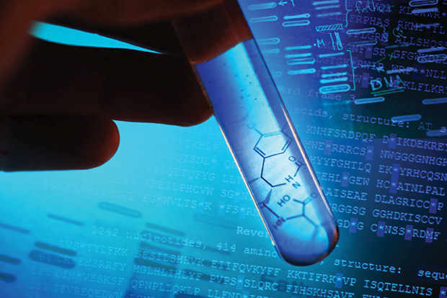
Cancer remains the leading cause of disease related death in children and young adults.
Children with many types of cancer have seen impressive improvement in survival rates over the last 50 years. Acute Lymphocytic Leukaemia, the most common children’s cancer known, has a 5-year survival rate of around 90% up from 50% in the 1970s. However, despite improvements in treatment some rarer types of children’s cancer have seen little or no improvement in survival rates.
The progress made in overall survival rates for children with cancer, although extremely welcome, comes at a cost due to the consequences of the cancer experience and treatment. Many former patients have long-lasting physical vulnerabilities like the risk of heart disease, development of secondary cancers, lack of fertility, and gradual loss of mobility. Certainly childhood cancers can bring opportunities for psychological growth, but some long-term survivors also live with learning disabilities and other neuropsychological long-term side-effects such as post-traumatic stress disorder. These in turn impact on relationships, employment opportunities, and overall wellbeing. At long last there is now a more profound acknowledgement and understanding of the harmful late side-effects that the survivors of childhood cancer face as they move on with their lives. These late effects are a direct result of the damage caused by conventional radiotherapy and chemotherapy that ultimately takes their toll on the rapidly developing child.
There have been great advancements in the treatment of adult cancer but this has not always been the case for children and young adults. This must change if we are to offer children and families the best treatments possible to enable them to survive and thrive.
Kidscan aims to be the charity of choice for researchers looking for support in the development of new therapeutic approaches for the treatment of children and young adults with cancer that limit, or if possible, prevent the debilitating long term side-effects of many current treatments.

General Research Objectives
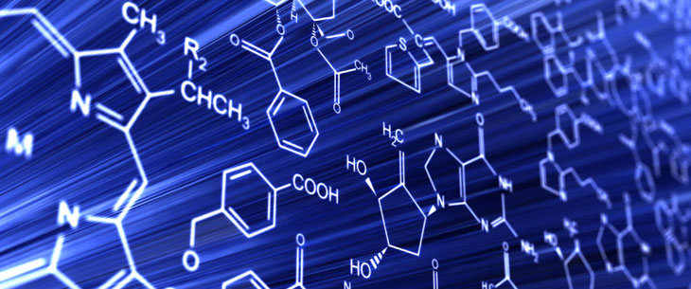
This research strategy was developed taking into account specific concerns of patient groups, clinician and research scientists working in the field of children’s cancer research. It also follows existing general guidance from comparable charities that fund scientific research. The research aims of Kidscan can broadly be summarised by the following key objectives:
- Grow a portfolio of research projects around our established research priorities and where possible wider issues in the field of childhood cancer.
- Engage with patients and clinicians to understand the specific areas that are currently a priority in the field of children’s cancer research
- Grow the pool or research talent in children’s cancer research and develop national and international research networks.
- Promote and disseminate the outputs of our research wherever possible.
- Ensure the translation of our funded research for public benefit.
- Use our research base to influence government/industrial policy on the challenges associated with the treatment of children and young adults with cancer.
- Encourage the widespread use of clinical trials in the treatment of children.

Specific Research Priorities
- We know more than ever before about the causes of children’s cancer but this increased knowledge has largely not been translated into new treatments. Translation of research data into the development of new drugs, so called “Bench to Bedside,” is vital in order to facilitate rapid advancement in clinical outcomes. Kidscan funded research should be translated into new treatments wherever possible or disseminated in a timely manner to the wider scientific community.

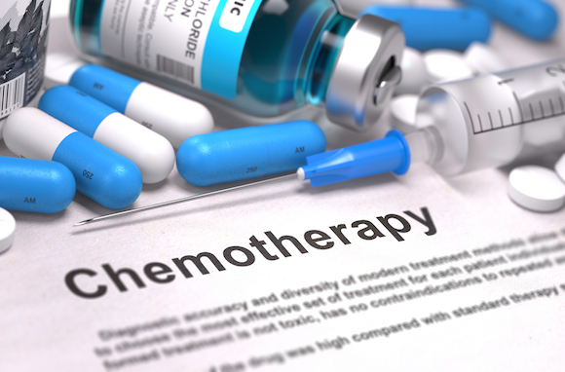
- There have not been many new chemotherapy drugs for children’s cancer over the last 20 years. We aim to fund world-class research into the discovery and development of new drugs for the treatment of children’s cancer.

- Funding of research into treatment development for very rare types of children’s cancer has always been limited. We must do more to focus research into these cancers were survival rates have lagged behind the more common childhood cancers.

- Getting more drugs into clinical trials is a key factor in improving patient outcomes. Children do better in terms of survival now than young adults because a bigger percentage of children are getting the newest treatments through clinical trials. Young adults appear to be falling behind in taking part in clinical trials and this is effecting outcomes in that age group. Improving the number of clinical trials for this age group should be a priority.

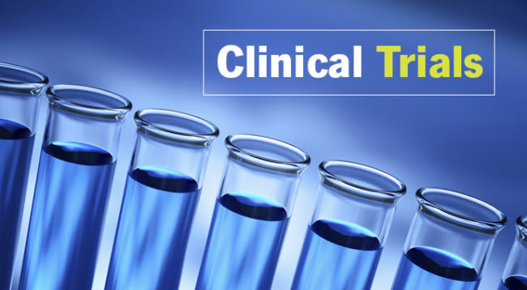
- The lack of clinical trials for all children with cancer is partially financial; the pharmaceutical companies need to make profits. Children’s cancer represents a tiny proportion of the total numbers of patients with cancer hence little scope for profit, this needs to be overcome. Kidscan will use its research base to influence policy in order to overcome obstacles to the introduction of new and existing drugs into the clinic.

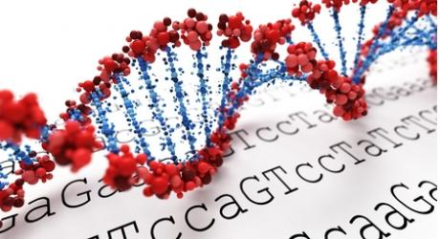
- Further investigation of the genetic causes of children’s cancer will be needed in order to develop the next generation of targeted medicines required to keep place with the advancements being made in personalised medicine.

- Many recently identified children’s cancer genes are not suitable for treatment with current targeted therapies, as they differ considerably from the cancer causing genes in adults. More needs to be done to develop new targeted therapies to these children’s cancer genes. This will ultimately minimise damage to normal healthy tissue and so alleviate the serious late side-effects for these patients.

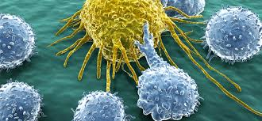
- Traditional approaches to cancer treatment, with associated side effects, won’t stop in the years ahead so new approaches are needed such as immunotherapy and gene editing. These need to be developed now, to allow a phased movement to more gentle treatments.

- Drug resistance in patients, who then relapse, is a big problem, we need understand the cellular/pharmacological basis for this resistance. This knowledge will allow personalised treatments to be developed that will minimise the risk of relapse and the return of cancers in previously cancer free patients.
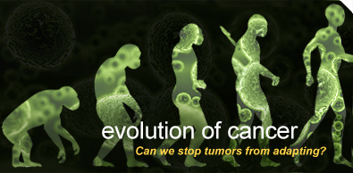

What Types of Funding Do We Offer?

A call for applications for specific grant schemes are usually made once or twice a year, following approval from the Kidscan Board of Trustees. The specific grant, schemes and details of the application, process will be advertised on the Kidscan website, appropriate research networks and where possible scientific journals/magazines. Current grants schemes include, PhD studentships, pump priming grants and placement student awards.

Ensuring we meet achieve our research objectives
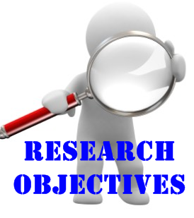
- In general, we will only fund research that meets the objectives of our strategic priorities. However, Kidscan will consider applications for innovative research outside of our specific priorities as long as the proposal furthers our understanding of childhood cancer and/or have the potential to improve the lives of patients and families.

- Applications will be judged on the basis of the projects alignment with our research objectives and scientific excellence. Only the best projects will be considered for funding by the scientific committee.

- Applications from the UK and overseas will be accepted and considered with equal merit

- Only qualified individuals may apply for research funding and this will be determined as part of the peer review process.

- Applicants must be employees of a suitable institution that can provide the infrastructure and training required to undertake the work proposed.

- Research proposals will first be assessed by teams of independent reviewers, who are experts in that field. The applications and reviewer’s reports will then be considered for funding by the Kidscan Scientific Committee who will make the final recommendations on funding allocations.

Monitoring Research Outputs and Impact

Evaluation of the value obtained from research funding is an important undertaking for all charities that support scientific research. Benchmarking of outputs and impacts from research funding is a long-term responsibility, and Kidscan are committed to both short- (annual and end of grant reports) and longer-term (5- to 10-year follow-up after grants finished) monitoring of outcomes from our research funding. This will be achieved by the periodic use of an online system for collecting data on outcomes , such as that offered by Researchfish.

This document aims to define the priorities, procedures and the support available to allow Kidscan to meet its research objectives over the next five years. This strategy will be reviewed and updated on an annual basis.

